* [**How to restore an item from the recycle bin as Site owner**](https://sharepoint.rackspace.com/learning/articles/pages/SharePoint-2013--how-to-restore-an-item-from-the-recycle-bin-as-site-owner.aspx)

1. From the homepage of your SharePoint site, on the Quick Launch click **Site Contents**.

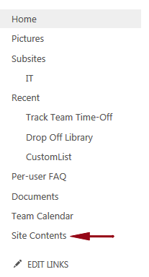

Lets delete something first.  Delete any list or library you would like. In this example I will delete “Team Tasks”.  
  
2. Still on the Site Contents page, click **RECYCLE BIN (1)**. Your number in parenthesis may be different.

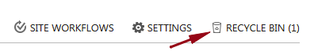

3. Check the box next to the item you want to restore, in this example “**Team Tasks**”.  
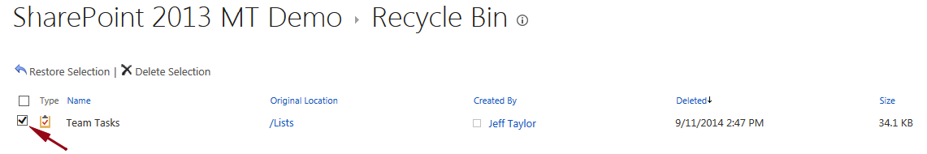

4. Click **Restore Selection**.  
https://sharepoint.rackspace.com/PublishingImages/Pages/SP2013%20how%20to%20restore%20from%20recycle%20bin%20site%20owner/recyclebinowner4.png

5. On the Message from webpage pop-up click **OK**.  
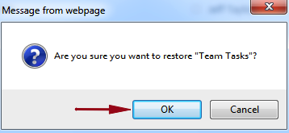

6. Click **Site Contents**.  
  
7. You will see the “Team Tasks” task list has been restored.

